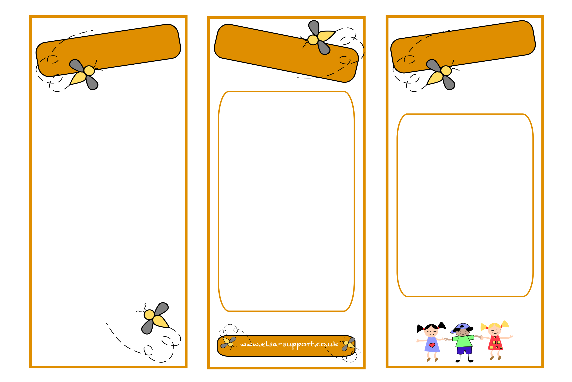
ELSAs can support with
An ELSA is a specialist Teaching/Learning Support Assistant who has experience working with children. ELSAs are trained and regularly supervised by the Educational Psychology Service in your Local Education Authority. An ELSA is a warm and caring person who wants to help your child feel happy in school and to reach their potential educationally. Their aim is help teach children emotional literacy skills to remove barriers to their learning and promote their wellbeing and happiness at school and home.
Please do talk to the SENCo and/or ELSA in your school if you think your child would benefit from this approach.

Loss and bereavement
Self-esteem
Social skills
Emotions
Friendships/social skills
Relationships
Anger management
Behaviour
Anxiety
Bullying
Conflict
Relaxation techniques
Emotional
Literacy
Support
Assistant

ELSA
What is an ELSA?
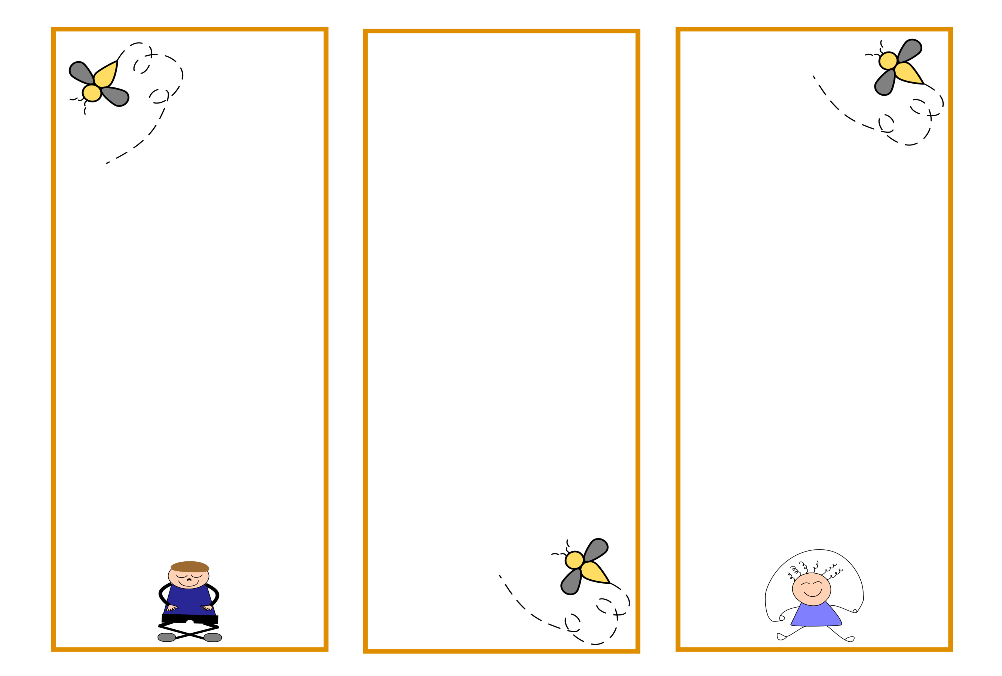
A loved pet has died
ELSAs have training in bereavement/loss/separation and understand that the loss of a pet is can be the first experience of death for your child. They will work with your child to help them feel supported in school.

A child expressing themselves through anger
The ELSA will take the child through an anger management intervention to help them recognise their anger triggers, techniques to avoid those triggers, and alternative strategies to help calm down .
The ELSA will plan their sessions for your child very carefully. The session consists of several parts, the first two parts consists of a circle-time where children sit in a circle and take turns to speak.
Emotional check in
This is an opportunity to talk about feelings,
Warm up activity
A fun game or activity to help relax your child.
Main activity
This is similar to the individual session but your child will be encouraged to work with other children. This helps with co-operation, social skills, friendship and gives a sense of belonging. A learning objective will be set for the group of children which they will all be able to answer at the end of the session.
Relaxation
Your child will be taught a relaxation exercise to help get them ready to go back to class

The ELSA will plan their sessions for your child very carefully. The session consists of several parts.
Emotional check in
This is an opportunity to talk about feelings,
Main activity
The ELSA will plan the activity to a learning objective. Something your child will be able to do at the end of the session that they cannot do now. This is usually a ‘I can ‘ statement such as ‘I can tell you about my strengths’ (A self-esteem objective). The ELSA will encourage your child to tell you about their talents or personal characteristics such as ‘kind’, ‘caring’, ‘helpful’ or ‘brave’. The child will then make something to reinforce those strengths.
Relaxation
Your child will be taught a relaxation exercise to help get them ready to go back to class
Your child will now be able to answer the question ‘I can tell you about my strengths’

Typical problems
Group session
Individual session

